The Effect of Various Pollutants on Respiratory Health in New York City, Delhi, and Rio

By Jackson Adame-Covey, Celine Aoun, Audrija Bhattacharya

ABSTRACT:

There is growing evidence on the effects of air pollutants such as particulate matter (PM_{2.5}, PM₁₀) and gases like NO_{x}, SO₂, CO, and O₃ on the human respiratory system, yet few studies and data sets exist for making comparative analyses across major cities worldwide. In this review of available literature, we assessed the relationship between ambient air pollution and upper respiratory tract infections and bronchial diseases in three global cities: New York City (USA), Delhi (India), and Rio de Janeiro (Brazil).
To perform this systematic review and meta-analysis, we conducted a search of PubMed to identify all relevant studies published before February 26, 2026, and then searched again for additional articles between March 13 and May 3, 2026. A total of 24 published articles were identified and screened to include studies that consisted of human subjects and exposures to ambient air pollution, and which reported bronchial diseases and respiratory tract infections, including asthma, infections, rhinitis, sinusitis, pharyngitis, and laryngitis.
In the final sample of 15 articles which met all the inclusion criteria, the most prevalent reported pollutant was PM_{2.5} which was identified as being associated with negative respiratory health outcomes in 6 studies (40%). PM₁₀ (36.36%) and SO₂ (27.27%) were the second and third most frequently reported pollutants associated with negative respiratory health outcomes. Results were stratified by the city studied in the tables listed in the results section, and by outcome in the figure also set in the results portion. The results for PM_{2.5} showed the most consistency across all the included studies.

INTRODUCTION:

Background & Objectives:
New York City, Delhi, and Rio de Janeiro are each among the most populous in their respective regions ¹³. Additionally, they are each perhaps the most influential metropolitans in their respective continents, with New York and Rio being bonafide cultural epicenters and Delhi being the capital of the world’s largest country. To us, this global importance meant that these three cities likely possessed problems representative of their larger regions. Thus, we supposed that examining risk factors within these areas would potentially have larger national and global health implications. Similarly, we know that 99% of the world lives in spaces where WHO air quality guideline levels are not met, contributing to 6.7 million premature deaths a year from three primary health outcomes: cardiovascular disease, respiratory disease, and cancer ⁵. Additionally, in light of the recent COVID-19 pandemic, we are aware that over 400 million people have experienced Long-COVID, a chronic condition that severely worsens respiratory health¹² . These facts led us to the conclusion that comparing which air pollutants are most impactful to respiratory health globally was necessary; to mitigate the nearly 7 million deaths attributed to air pollution annually and account for the worsening of generalized respiratory health from Long-COVID , we must first know exactly how to tailor our efforts from place to place.
That being said, a systematic review addressing such a comparison is currently not available. Nevertheless, two systematic reviews related to air quality and respiratory health/Asthma do exist. The first of said two reviews examined short-term and long-term exposure effects of PM_{2.5}, ozone, NO_{X}, SO₂ and CO on general respiratory health symptoms and asthma¹⁵. The second of those reviewed studies related to pollutant characteristics associated with biomass burning and fossil fuel combustions conducted in Brazil¹⁹. The two reviews identified aim to investigate the association between air pollution and respiratory health but are not comparative in nature. The main objective of this paper is thus to fill this knowledge gap by comparing the effect of a wide variety of air pollutants on respiratory health in different parts of the world.
We will complete this objective by performing a comparative systematic review of air pollutants’ impacts in New York, Delhi, and Rio De Janeiro with the following research question: What are the most common air pollutants that lead to upper respiratory tract infections and bronchial diseases in New York City, Delhi, and Rio De Janeiro? New York City includes the city and its boroughs: Manhattan, the Bronk, Brooklyn, Queens, and Staten Island. Rio De Janeiro includes everything within Rio’s city limits, and Delhi includes the municipality of New Delhi as well as the larger metropolitan area of Delhi. We included two main categories of respiratory diseases, those being respiratory tract infections and bronchial diseases, based upon PubMed mesh term categorization of the diseases we found most prevalent throughout our research. Generally, we found the following air pollutants to most commonly lead to negative health effects: PM_{2.5}, PM₁₀, NO_{X}, ozone, sulfur dioxide, carbon monoxide, VOC’s, and dust.
METHODS
A systematic search using the PubMed database was done to identify studies investigating the association between air pollution and upper respiratory health outcomes in New York City, Delhi, and Rio de Janeiro.
All searches were performed between February 26, 2026 and May 3, 2026, with the final reproducible search executed on May 3, 2026. Initially, to identify relevant keywords and Medical Subject Headings (MeSH) terms, initial searches were independently conducted for each city. These exploratory searches facilitated the development of a final, combined Boolean search string. Said search string is as follows: (("New York"[tiab] OR "New York City"[tiab] OR "NYC" [tiab] OR "Manhattan"[tiab] OR "Brooklyn"[tiab] OR "Bronx" [tiab] OR "Queens"[tiab] OR "Staten Island"[tiab] OR "Rio de Janeiro"[tiab] OR "Rio de Janeiro, Brazil"[tiab] OR "RJ"[tiab] OR "Delhi"[tiab] OR "New Delhi"[tiab] OR "Delhi, India"[tiab]) AND ("Upper Respiratory Tract Infections"[Mesh] OR "upper respiratory"[tiab] OR "upper respiratory infection"[tiab] OR "rhinitis"[tiab] OR "sinusitis"[tiab] OR "pharyngitis"[tiab] OR "laryngitis"[tiab])) AND ("Air Pollution"[Mesh] OR "Particulate Matter"[Mesh] OR "Nitrogen Dioxide"[Mesh] OR "Ozone"[Mesh] OR "Sulfur Dioxide"[Mesh] OR "Carbon Monoxide"[Mesh] OR "PM2.5"[tiab] OR "PM10"[tiab] OR "NO2" [tiab] OR "ozone"[tiab] OR "SO2"[tiab] OR "diesel exhaust"[tiab]))
In addition to the search string itself, we applied various filters. Said filters applied in PubMed included: Language: English, Species: Humans, and Availability: Full-text accessible through the UNC library. This search yielded 21 results on May 3, 2026.
We similarly used various inclusion criteria regarding population, exposure, outcomes, and study design. We included three populations: humans in New York City (including boroughs), Delhi (including New Delhi), and Rio de Janeiro. We included the following air pollutants: PM_{2.5}, PM₁₀, NO_{X}, ozone, sulfur dioxide, carbon monoxide, and diesel exhaust. Outcomes included upper respiratory tract infections, rhinitis, sinusitis, pharyngitis, and laryngitis. We included the following empirical, quantitative study designs: cohort studies, cross-sectional studies, case-crossover studies, ecological studies, and randomized or quasi-experimental studies. We similarly included the following publication characteristics: peer-reviewed, full-text access through UNC, and articles written in English.
Studies were excluded if they met any of the following characteristics: non-human, non-english, articles without full access through UNC, studies not conducted in New York City, Delhi, or Rio de Janeiro, studies that did not assess both air pollution exposure and upper respiratory health outcomes, studies lacking original quantitative data, editorials, commentaries, letters, or opinion pieces, systematic reviews, narrative reviews, and meta-analyses (excluded from quantitative analysis and figures to avoid duplication, though retained for contextual understanding during screening). We similarly excluded all sources that did not directly examine the relationship between a given exposure and respiratory health.
Before performing data extraction, we conducted a screening process. All studies that were identified and selected were screened in two stages. First, titles and abstracts were reviewed to evaluate the relevance based on population, exposure, and outcomes. Second, full-text articles were assessed against the inclusion and exclusion criteria. Studies were excluded during full-text review if they did not include a defined air pollution exposure, did not assess a relevant upper respiratory outcome, or did not meet geographic or study design requirements. Initially, we performed data extraction in an individual, stratified manner, with each of us performing research on a separate country using different search strings. Following this initial surface level research, we consolidated our search strings into the above larger string and began performing data extraction in a collaborative manner.

RESULTS:

Search Results
The search results yielded 21 articles on May 3, 2026, all of which were manually screened. Articles which denied full text access and articles not pertaining to the exposures of interest were then manually removed, leaving 15 articles. Table 1 includes descriptive statistics for articles in each variable category.

Table 1. Descriptive Statistics Table

Variable | n(%) (n= number of articles that contain information regarding the category, % = percentage of articles out of 15 total) | Citations
City
New York City | 6(40%) | ^{2, 7, 8, 9, 15, 18,}
Delhi | 5(33.33%) | ^{4, 6, 11, 16, 17}
Rio | 4(26.67%) | ^{1, 3, 10, 14}
Exposures
PM_{2.5} | 8(53.33%) | ^{1, 2, 4, 6, 8, 10, 11, 20}
CO | 6(40%) | ^{1, 3, 4, 10, 17, 20}
PM₁₀ | 6(40%) | ^{3, 4, 6, 11, 14, 16}
NO_{x} | 4(26.67%) | ^{1, 3, 8, 17}
SO₂ | 4(26.67%) | ^{4, 8, 11, 17}
O₃ | 3(20%) | ^{2, 14, 16}
Dust | 2(13.33%) | ^{7, 18}
VOCs | 1(6.67%) | ⁹
Outcomes
Bronchial | 5(33.33%) | ^{4, 6, 9, 10, 20,}
Respiratory Tract Infections | 4(26.67%) | ^{2, 7, 16, 18}
Other* | 6(40%) | ^{1, 3, 8, 11, 14, 17}
Sexes Included
Both Sexes | 14(93.33%) | 2, 3, 4, 6, 7, 8, 9, 10, 11, 14, 16, 17, 18, 20
Female Only | 1(6.67%) | ¹
Male Only | 0(0%) | N/A
Age Ranges Included
No Age Range Specified | 9(60%) | ^{2, 4, 8, 9, 11, 14, 16, 17, 18}
<18 years old | 3(20%) | ^{6, 10, 20}
18-60 years old | 2(13.33%) | ^{1, 7}
>60 years old | 1(6.67%) | ³
Socioeconomic Status Included
No Status Specified | 12(80%) | 2, 3, 4, 7, 8, 9, 10, 11, 14, 16, 17, 18
Higher Socioeconomic Status** | 2(13.33%) | ^{1, 6}
Lower Socioeconomic Status*** | 1(6.67%) | ²⁰
Population Size
10,000-1,000,000 | 5(33.33%) | ^{4, 8, 11, 14, 18}
1-10,000 | 3(20%) | ^{1, 7, 10}
Other**** | 7(46.67%) | ^{2, 3, 6, 7, 9, 16, 17}

* Outcomes not defined as bronchial diseases or respiratory infections
**Determined by attendance at a private school/ university
*** Determined by Medicaid usage
**** Population measurement does not have a defined numerical value

The most prevalent city in the search criteria was New York City, with 6 out of 15 articles focusing on conditions in that city. This was followed up by Delhi, with 5 articles, and Rio with 4. The most prevalent pollutant was PM_{2.5}, with 8 out of 15 articles including it as an exposure criteria in their study design. The least prevalent pollutants were dust and volatile organic compounds (VOCs), with only 2 and 1 articles out of 15 mentioning them. All articles mentioning dust and VOCs were focused on New York City. Most studies reviewed a mixed-gender population under 1,000,000, with one article reviewing women only, and 7 articles having a sample population that was not numerically defined.

Identifying Pollutants with the Strongest Associations to Negative Health Outcomes
Figure 1. Heat Map with Number of Articles that Found Association Between a Pollutant and Adverse Health Outcome by City Among 15 Articles
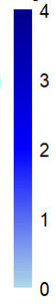
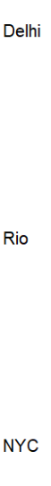
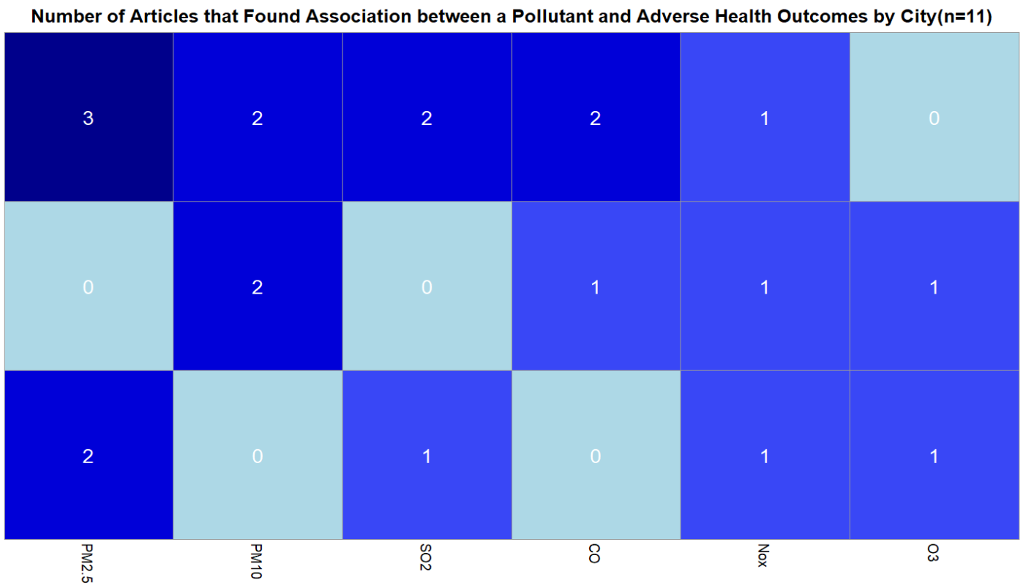

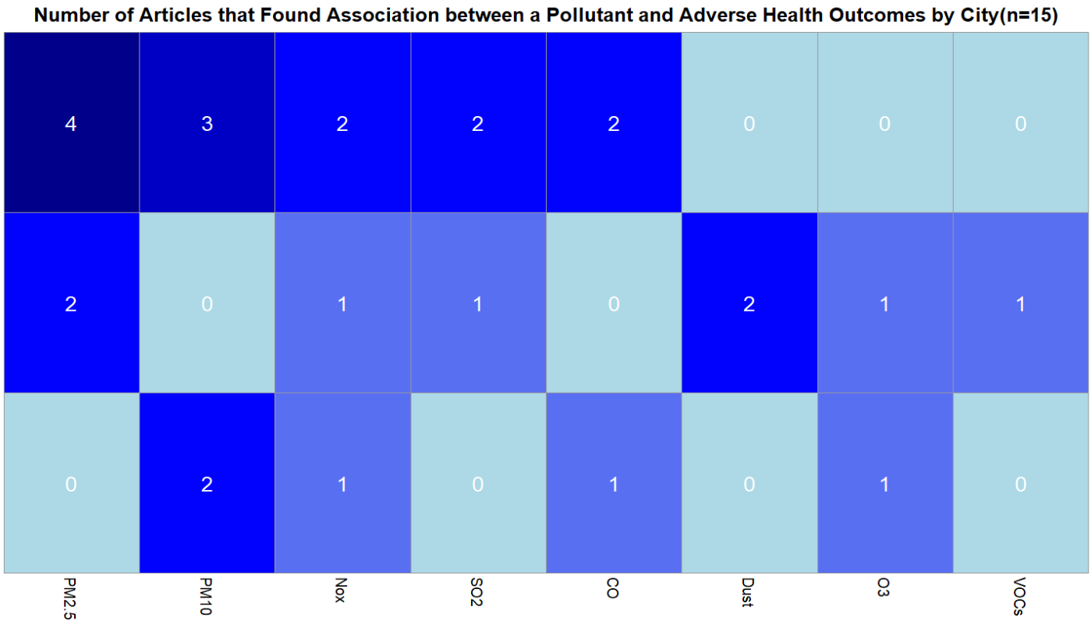

Figure 1 shows that the pollutant with the most frequent association to negative health outcomes found in the literature is PM_{2.5}, with 6 articles finding a statistically significant association between it and a negative health outcome. Notably, there are no articles finding an association between PM_{2.5} and negative health outcomes in Rio. PM₁₀ followed closely behind, with 5 articles finding a statistically significant association between it and negative health outcomes. All other pollutants have at least 1 article with an association to negative health outcomes found. Overall, the city that had the highest number of articles finding an association between any pollutant and negative health outcomes was Delhi, with 13 statistically significant associations found within the 5 articles in the review pertaining to it. On the low end, Rio had only 5 statistically significant associations found within the 4 articles in the review pertaining to it.

Discussion

The city with the most numbers of articles found from the search used was New York City, and the city with the least number was Rio De Janeiro. This may indicate a gap in the current research literature surrounding health consequences of air pollution in Rio. The most prevalent pollutant found in the literature overall was PM_{2.5} , with 8 articles including it as an exposure, and the pollutant with the most significant association to negative health outcomes was also PM_{2.5}. This indicates that the current literature is correct to focus on PM_{2.5} as an exposure more as opposed to other air pollutants.
The most interesting finding was that despite there being many articles finding a statistically significant association between PM_{2.5} and negative health outcomes in Delhi and New York City, there were 0 articles with this finding from Rio. This may indicate a serious research gap, as either there is a lack of understanding of PM_{2.5}’s effects on health in Rio, or there may be little to no adverse health effects from PM_{2.5} in Rio, which could act as a guidepost for strategies to reduce these negative health outcomes from PM_{2.5} in Delhi and New York City. Future research investigating the role of PM_{2.5} in Rio would advance public health efforts by helping scientific communities to reduce the presence of pollutants and their association to negative population health effects in metropolitan areas.
Additionally, if we were to perform this research again, we would revise our search string to include dust and VOC’s, two air pollutants that we did not explicitly include in our search. Notably, however, with our current search string, we nevertheless found and performed data extraction on 3 sources that discussed VOC’s and dust. With a search string revision, we anticipate we would find more sources focusing primarily on VOC’s and dust, potentially making them more prevalent, impactful air pollutants.

References:
- Kelkar, H., Sharma, A. K. & Chaturvedi, S. Association of air pollution and lung function of young adult females in New Delhi. Journal of Health and Pollution 9, 190611 (2019).
- Kim, H. & Bell, M. L. Air pollution and COVID-19 mortality in New York City. American Journal of Respiratory and Critical Care Medicine 204, 97–99 (2021).
- Costa, A. F., Hoek, G., Brunekreef, B. & De Leon, A. C. M. P. Air Pollution and Deaths among Elderly Residents of São Paulo, Brazil: An Analysis of Mortality Displacement. Environmental Health Perspectives 125, 349–354 (2016).
- Kumar, R. et al. Air pollution and its effects on emergency room visits in tertiary respiratory care centres in Delhi, India. Monaldi Archives for Chest Disease 94, (2023).
- World Health Organization: WHO. Ambient (outdoor) air pollution. https://www.who.int/news-room/fact-sheets/detail/ambient-(outdoor)-air-quality-and-health (2024).
- Salvi, S. S. et al. Association between air pollution, body mass index, respiratory symptoms, and asthma among adolescent school children living in Delhi, India. Lung India 38, 408–415 (2021).
- Kwon, S. et al. Blood eosinophils and World Trade Center Exposure predict surgery in chronic rhinosinusitis. a 13.5-Year longitudinal study. Annals of the American Thoracic Society 13, 1253–1261 (2016).
- Feathers, A. et al. Crohn’s Disease mortality and ambient air pollution in New York City. Inflammatory Bowel Diseases 30, 1732–1739 (2023).
- Madani, N. A., Jones, L. E. & Carpenter, D. O. Different volatile organic compounds in local point source air pollution pose distinctive elevated risks for respiratory disease-associated emergency room visits. Chemosphere 344, 140403 (2023).
- Kuschnir, F. C. & Da Cunha, A. J. L. A. Environmental and socio‐demographic factors associated to asthma in adolescents in Rio de Janeiro, Brazil. Pediatric Allergy and Immunology 18, 142–148 (2006).
- Dutta, A. & Jinsart, W. Air pollution in Delhi, India: It’s status and association with respiratory diseases. PLoS ONE 17, e0274444 (2022).
- Al-Aly, Z. et al. Long COVID science, research and policy. Nature Medicine 30, 2148–2164 (2024).
- Population by country (2026) - Worldometer. Worldometer https://www.worldometers.info/world-population/population-by-country/.
- Cortes, T. R., Silveira, I. H., De Oliveira, B. F. A., Bell, M. L. & Junger, W. L. Short-term association between ambient air pollution and cardio-respiratory mortality in Rio de Janeiro, Brazil. PLoS ONE 18, e0281499 (2023).
- Mananga, E. S., Lopez, E., Diop, A., Dongomale, P. J. & Diane, F. The impact of the air pollution on health in New York City. Journal of Public Health Research 12, 22799036231205870 (2023).
- Romieu, I. et al. Multicity study of air pollution and mortality in Latin America (the ESCALA study). Res Rep Health Eff Inst 5–86 (2012).
- Aneja, V. P. et al. Measurements and analysis of criteria pollutants in New Delhi, India. Environment International 27, 35–42 (2001).
- Antao, V. et al. 9/11 Residential Exposures: The impact of World Trade Center dust on respiratory outcomes of Lower Manhattan residents. International Journal of Environmental Research and Public Health 16, 798 (2019).
- Oliveira, B. F. A. de, Ignotti, E. & Hacon, S. S. A systematic review of the physical and chemical characteristics of pollutants from biomass burning and combustion of fossil fuels and health effects in Brazil. Cad. Saúde Pública 27, 1678–1698 (2011)
- Titus, A. R. et al. A matched analysis of the association between federally mandated Smoke-Free housing policies and health outcomes among Medicaid-Enrolled children in subsidized Housing, New York City, 2015–2019. American Journal of Epidemiology 192, 25–33 (2022).

AI Attestation:
We attest that we used AI in forming the search strings for the report and summarizing articles for the purpose of data extraction, but not in any other components.

Appendix
Below is a bulleted list of the edits we made to our interim report.
- Review “shared systematic literature review study” and add detail/take out unnecessary details in abstract. Make results more quantitative, describing things like “how many articles did you yield after the search? Also, how many percentages of the article supports that PM2.5 was the most harmful pollutant ?”
- Review technical writing slides to revise Background and include all necessary concepts. Also, make it a bit longer (about three paragraphs) and ensure to include in-text citations. The first paragraph should be a research question and objectives instead of background.
- Revise “Research Question & Objectives” section to better detail the rationale behind the chosen cities, pollutants, and health effects. Also, ensure we’re properly using subscripts and superscripts in pollution names.
- Revise Methods (systematic search strategy) to be a paragraph, rather than a list.
- Finish data extraction
- Revise “Results: Tables, Figures, and Visualizations” to include all data extractions and align better with the research question.
- “Revise Results:narrative synthesis” to better synthesize a conclusion and perform higher-level pattern interpretation.
- Revise Discussion section to have more depth, critical insight, and a strong linkage to global health
- Write appendix that addresses all revisions we made to the interim report

